Setting Up A Skype Call

Downloading and Creating a Skype Account
Firstly, it would be a good idea to create a Skype account, if you have not got one already. It is free to download and set up a Skype account and you can do so here:
https://www.skype.com/en/get-skype/
You don’t have to download or create a Skype account; you can simply create a session here:
https://www.skype.com/en/free-conference-call/
However, we do recommend you download Skype and that you create an account.
Creating a call
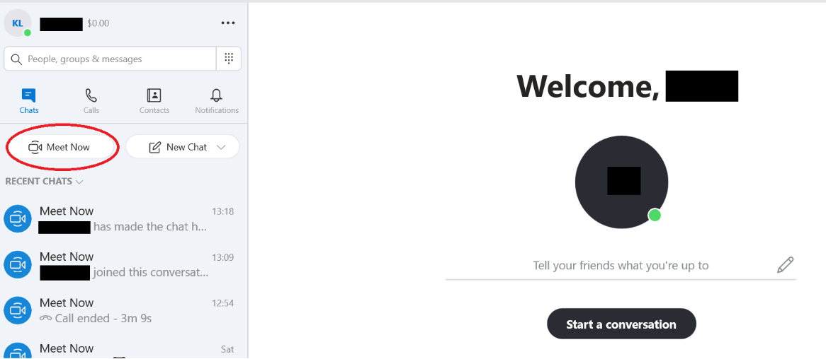
When logged into Skype, you can create a meeting/session by clicking ‘meet now’ in the top left of your screen.

Once you’ve clicked this, Skype may ask you and your participants if they would like to allow Skype to use their Camera and Microphone. Make sure you click ‘yes’ to this option.
Inviting participants
Step 1:
To invite participants, click ‘Share Invite’ and click either:
- Copy link (this can then be pasted into an email which you send to you participants
- Outlook (this will create a link within an Outlook email where all you have to do is add in your participants)
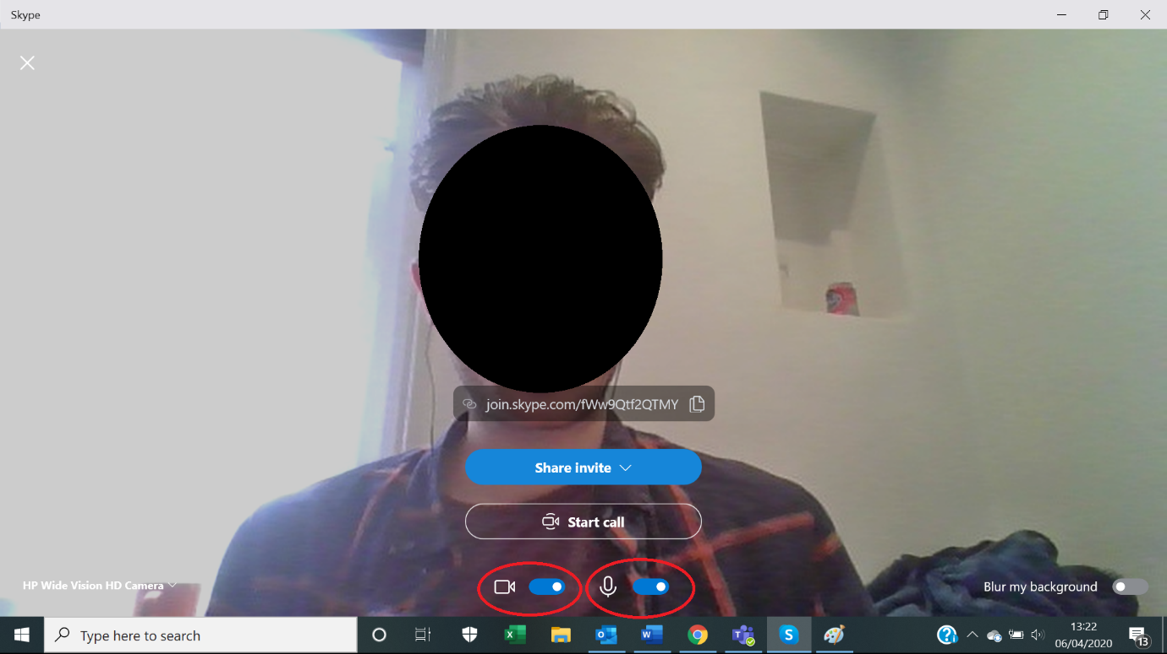
- Gmail (this will create a link within an Outlook email where all you have to do is add in your participants)

Important:
- Your link changes for each session you run, so you can’t send out the link the day before, you can only send out the real link when you’re ready to deliver the session
- Remember to include all your participants in the email!

After you have sent the email, make sure you have your Microphone and Camera on (circled in red) and then click ‘Start Call’.
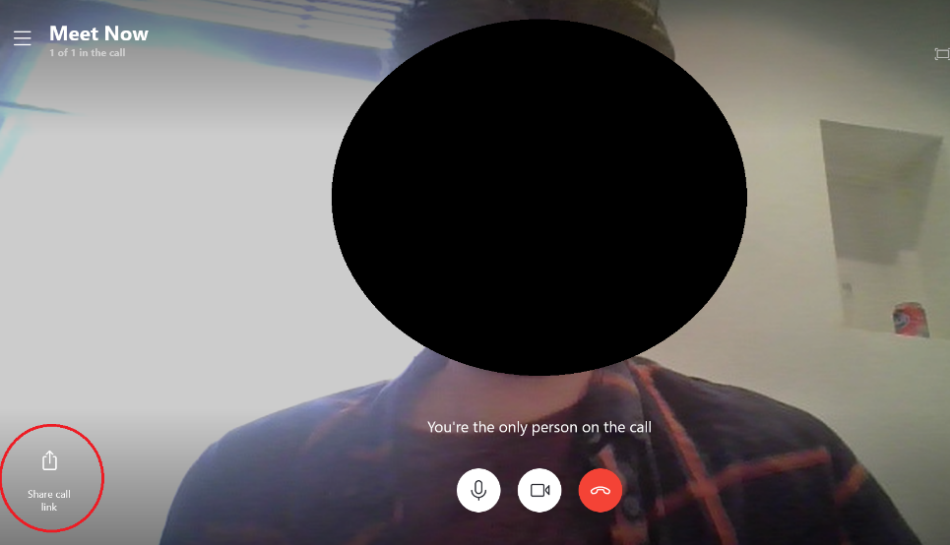
If you forget one of your call participants, you can add them by clicking the link in the bottom left corner.

If you haven’t downloaded Skype, again you will have to use the following link:
https://www.skype.com/en/free-conference-call/
How participants join
Feel free to copy and paste this information into an email to your participants so that they feel comfortable in being able to join:
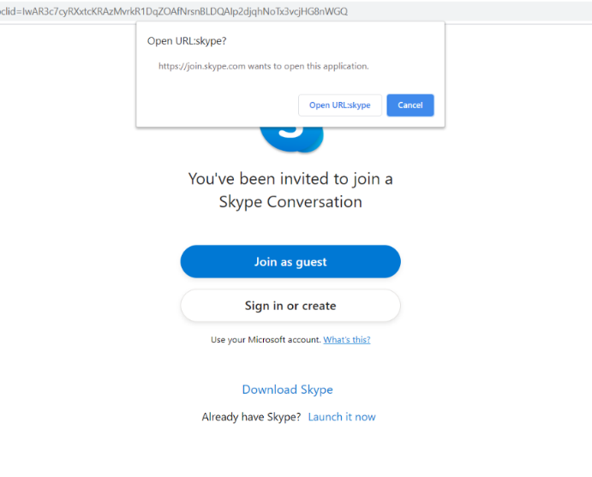
Step 1) After clicking on the invite link, you will see the following screen. If you have a Skype account you can sign in or you can click ‘join as guest’. You do not need to download Skype.

Step 2) You will be asked to put in your name. Please make sure you do this as it means the facilitator will be able to know who you are! Click ‘Join’ once you have done this.

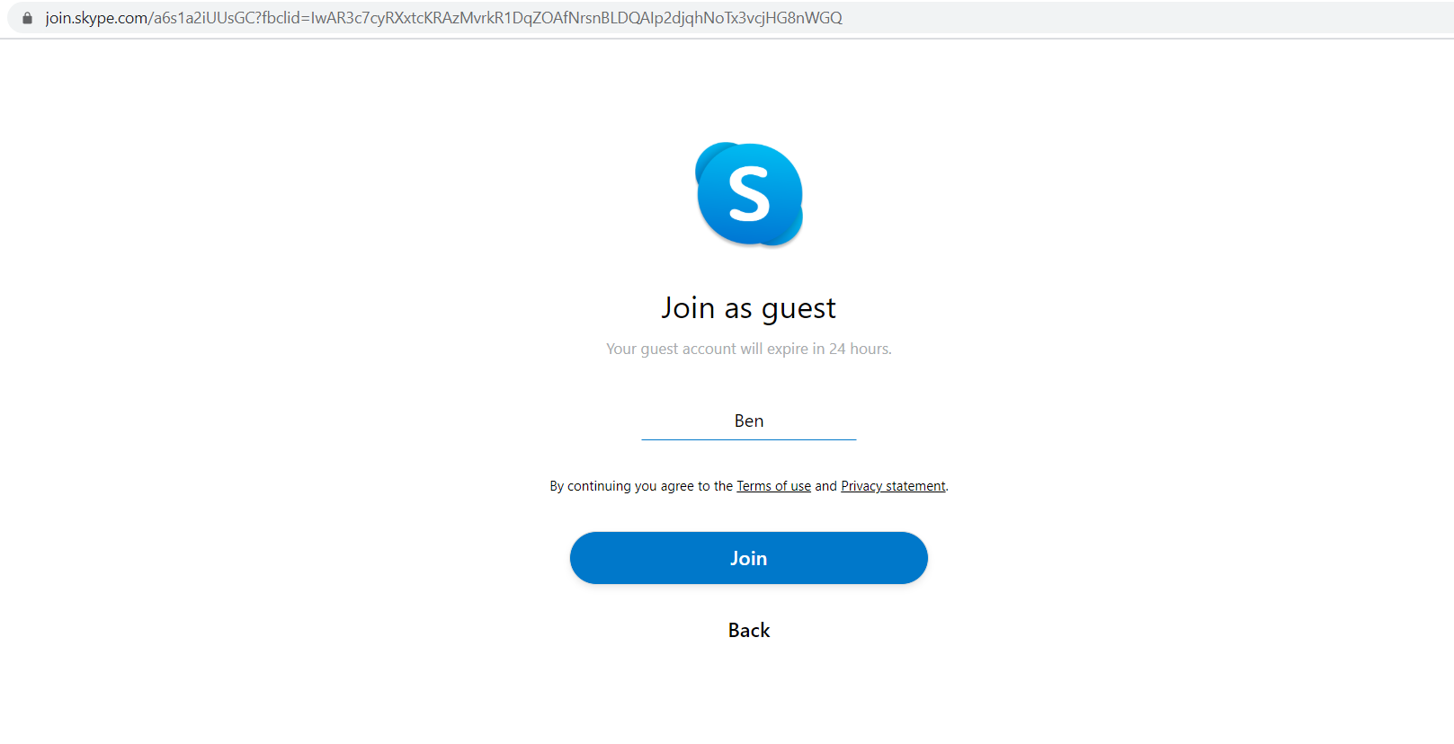
Step 3) Lastly, you will see this screen before you join. If your computer, laptop or tablet has the capacity to, flip the video and audio switches on so that the facilitator can hear and see you!
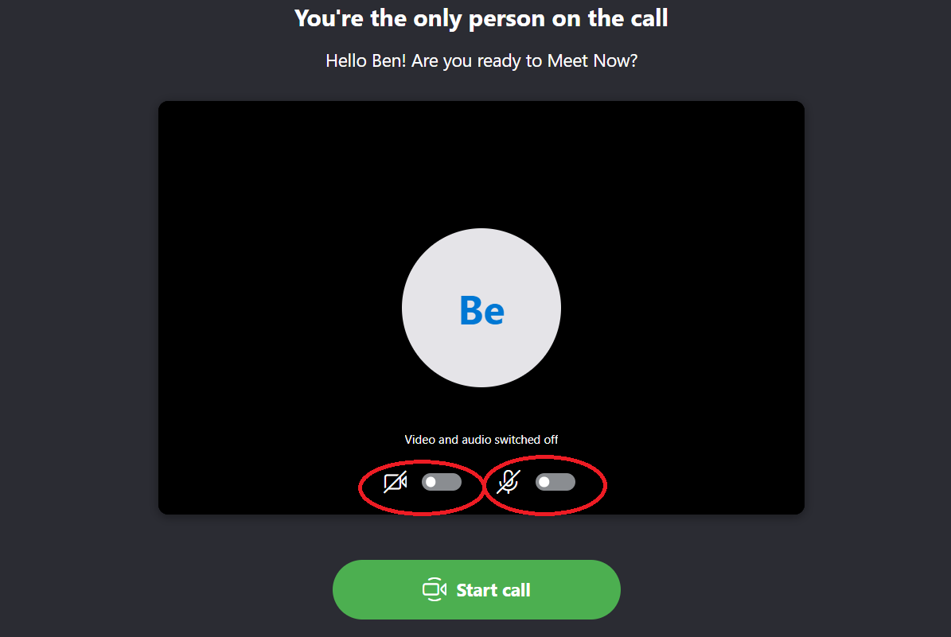

Muting participants
You can mute and unmute participants by clicking on the button circled in red:
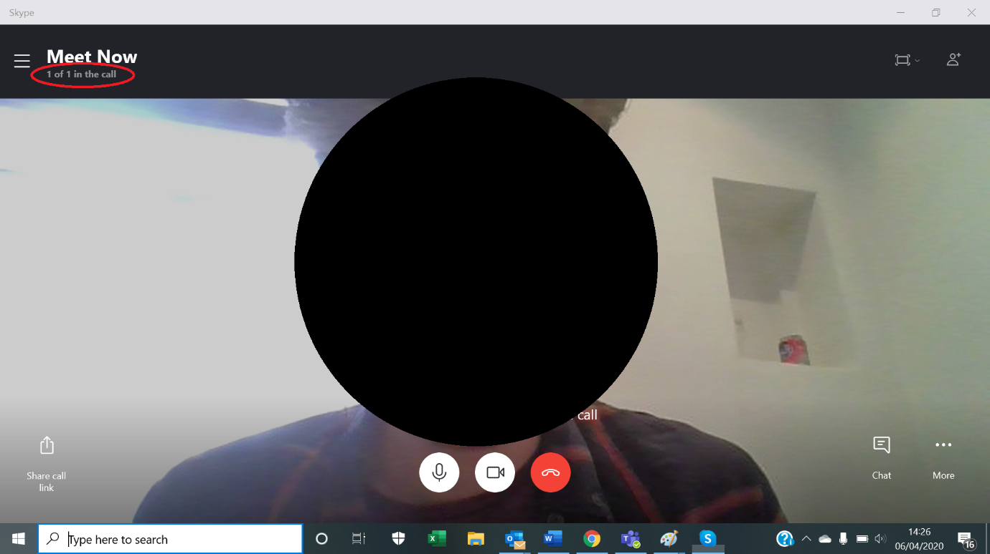

By clicking on this button, you will be taken to a full list of who is and who isn’t muted. By clicking on the microphone icons, you can mute and unmute participants.
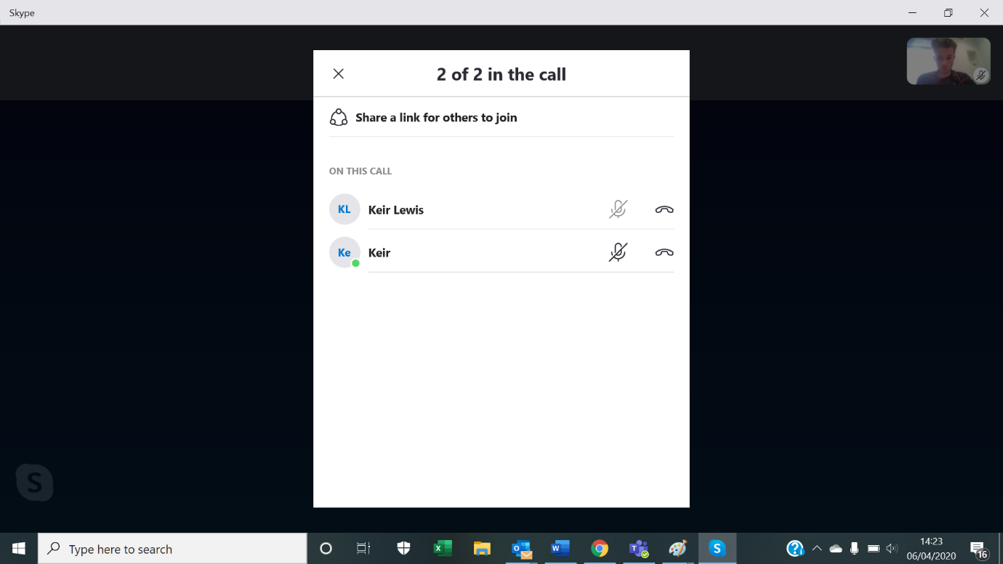

Participants will be able to mute and unmute themselves, however if participants are struggling to mut themselves, you can follow the steps above.
Sharing your screen
To do this, you can click on the ‘Share screen’ option circled in red. Then click ‘Your entire screen’ and ‘Share’ in the following step.
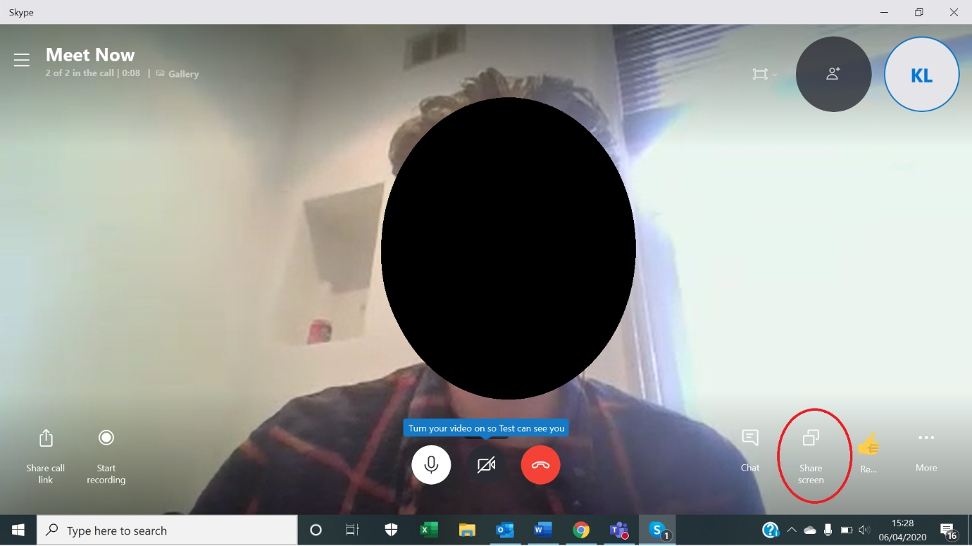

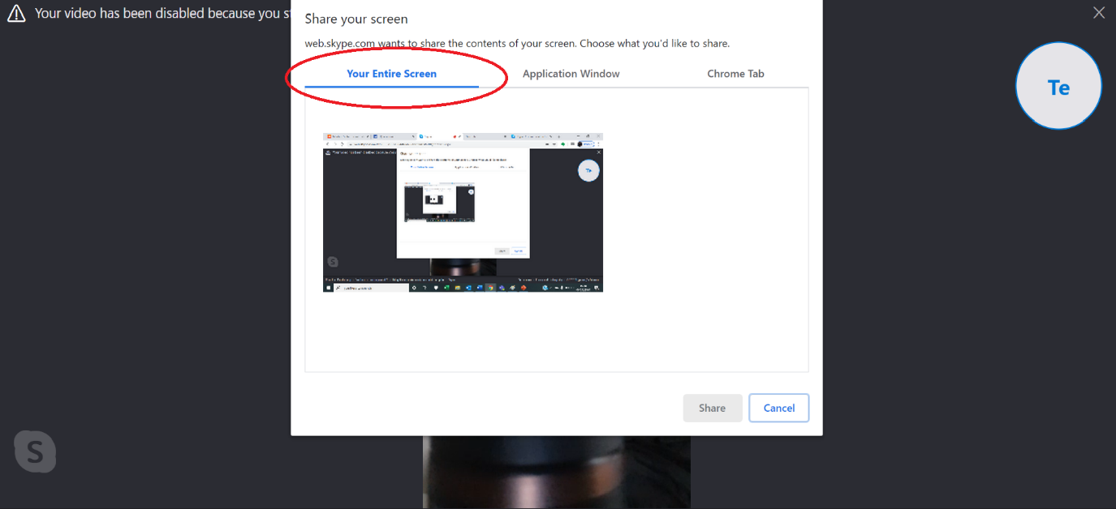
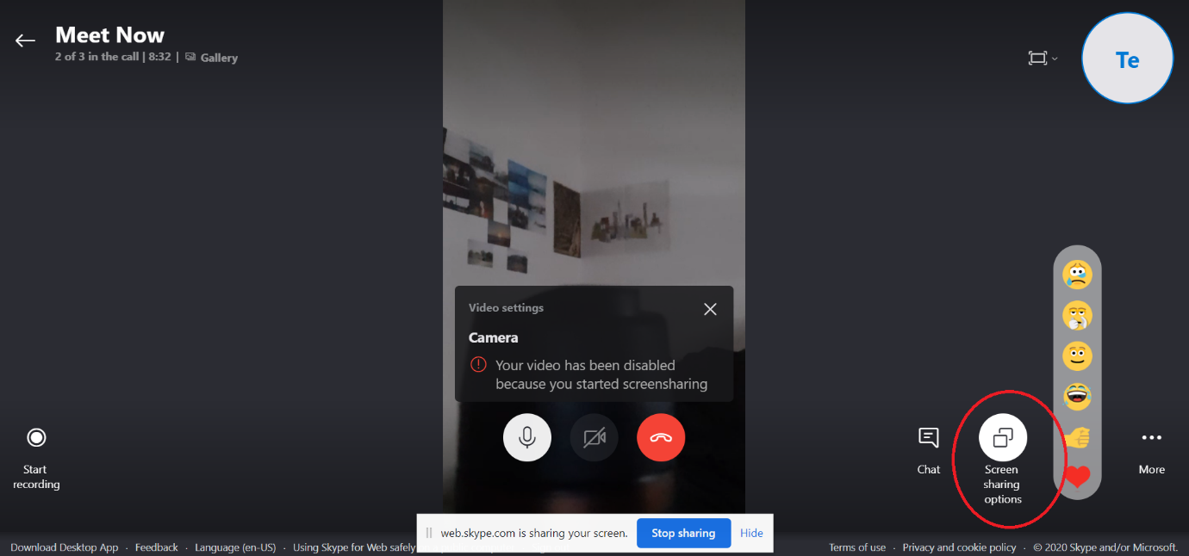
You can back out of the screen sharing when you necessary by returning to your Skype tab and clicking ‘Screen sharing options’. See the button circled in red:

