Getting The Most Out Of ZOOM

This document covers:
- Using Breakout Rooms
- Using Polls
- Using the Cohosting Feature
- Optimising Video & Audio when sharing clips

Using Breakout Rooms
Breakout rooms are useful for encouraging conversation in smaller groups and is a feature available on free and paid accounts.
You must make sure that breakout rooms are enabled on your account for them to work!

Enabling Breakout Rooms
- Sign in to the Zoom web portal at https://zoom.us/signin.
- Go to Settings, then In Meeting (Advanced)
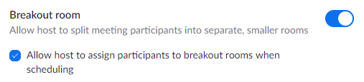
- Find the Breakout Room option, and make sure it’s enabled by toggling the slider to blue.

- (Optional) Click the checkbox to allow meeting hosts to pre-assign participants to breakout rooms. This can be useful to do if you know who’s going to be attending a meeting, and you want to make sure two tricky people don’t end up in the same room with each other(!) or if you want to allocate a facilitator to each room in advance. There’s some helpful instructions for how to do this here: https://support.zoom.us/hc/en-us/articles/360032752671 Alternatively you can just allocate people to rooms when you put people into breakout rooms during the meeting – if you don’t feel too under pressure. This is what I normally do.

Creating Breakout Rooms
- During a meeting, just click on the Breakout Rooms icon:

- Select the number of rooms you would like to create, and how you would like to assign your participants to those rooms:
- Automatically: Let Zoom split your participants up evenly into each of the rooms.
- Manually: Choose which participants you would like in each room.
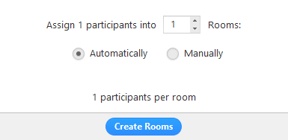
- Click Create Breakout Rooms.
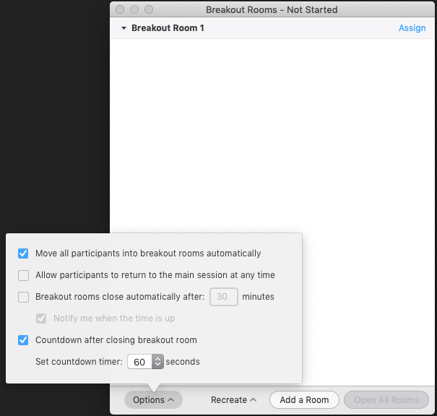
- Click Options to choose the additional options for your rooms.

- Check any options that you would like to use for your breakout rooms.
- Allow participants to choose room: Participants can select and enter rooms on their own once rooms are launched.
- Allow participants to return to the main session at any time: If this option is checked, the participants can move back to the main session from their meeting controls. If this is disabled, they need to wait for the host to end the breakout rooms.
- Automatically move all assigned participants into breakout rooms: Checking this option will move all participants into the breakout rooms automatically. If this option is unchecked, the participants will need to click Join to be added to the breakout room.
- Auto close breakout rooms after () minutes: If this option is checked, the breakout rooms will automatically end after the chosen time.
- Notify me when the time is up: If this option is checked, the host will be notified when the breakout room time is up.
- Set Countdown timer: If this option is checked, the participants will be given a countdown of how much time they have left before being returned to the main room.
- Assign your participants to each room, by clicking Assign next to each room, and selecting the participants you want to be in that room. Repeat for each room.

Once a participant has been assigned (manually or automatically), the number of participants will show in place of the Assign button.

- You can rearrange the participants if needed. Participants who are not assigned to breakout sessions will remain in the main meeting when the rooms are started – so make sure everyone is assigned a room!
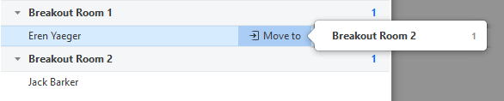
- Move to (participant): Select a room to move the participant to.

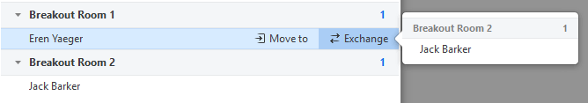
- Exchange (participant): Select a participant in another room to swap the selected participant with.

- Once you’re happy with how you’ve allocated the rooms, click Open All Rooms. All assigned participants will be moved to their respective rooms after confirming the prompt to join the breakout room. If allowing participants to choose their own room, they can open the list of rooms and choose which to join. The host will be left in the main meeting until manually joining one of the rooms. The participants (and the host when manually joining a room) will see the following message shown when joining the breakout room.
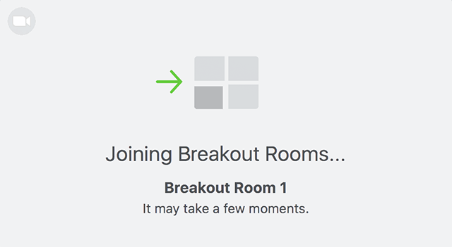
Managing Breakout Rooms
- Once the breakout rooms have been started, you as host will stay in the main meeting until you chose to join a room manually, by clicking Join.
- If a participant has not joined the session yet, it will be noted by (not joined) next to their name.
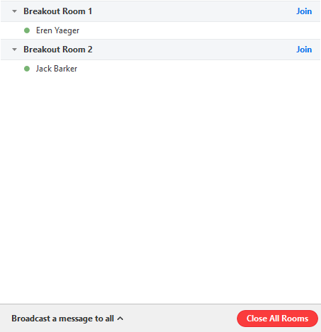
- To close the breakout rooms, click Close All Rooms. This stops all rooms after a 60 second countdown (which everyone can see) and returns all participants back to the main meeting.

- Participants in breakout rooms can request that the meeting host join their meeting by clicking Ask for Help.

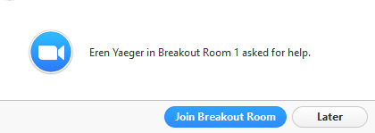
You will be prompted to join the room where the request originated from. Click Join Breakout Room to join the room.

- As host, you can broadcast a message to all breakout rooms to share information with all participants. E.g. ‘We’ll be returning to the main room in 5 minutes.’ To do this click Breakout Rooms in the meeting controls, then click Broadcast a message to all, enter your message and click Broadcast.

How many rooms can I have?
You can create up to 50 breakout rooms. The maximum number of participants in a single breakout room depends on the meeting capacity, number of breakout rooms created, and if participants are assigned during the meeting or before the meeting. If you’re hosting a really large meeting (more than 200 participants), then make sure to check your zoom package to see what your limits are.

Using Polls
Polls are a great feature of paid Zoom accounts to survey your attendees with simple questions during a meeting.
You must have Polls enabled in your settings, and have set up your poll in advance of your meeting.

Enabling Polls
- Sign in to the Zoom web portal at https://zoom.us/signin.
- Go to Settings, then In Meeting (Basic)
- Find the Polling option, and make sure it’s enabled by toggling the slider to blue.
Creating a Poll
- Still in your account on the Zoom web portal, Go to the Meetings page.
- Find your scheduled meeting in which you want to use the poll and click into it.
- Scroll to the bottom of the page to find the Poll option. Click Add to begin creating the poll.

- Enter a title and your first question.
- (Optional) Check the box to make the poll anonymous, which will keep the participant's polling information anonymous in the meeting and in the reports.
- Select whether you want the question to be single choice(participants can only choose one answer) or multiple choice question(participants can choose multiple answers).
- Type in the answers to your question and click Save at the bottom.
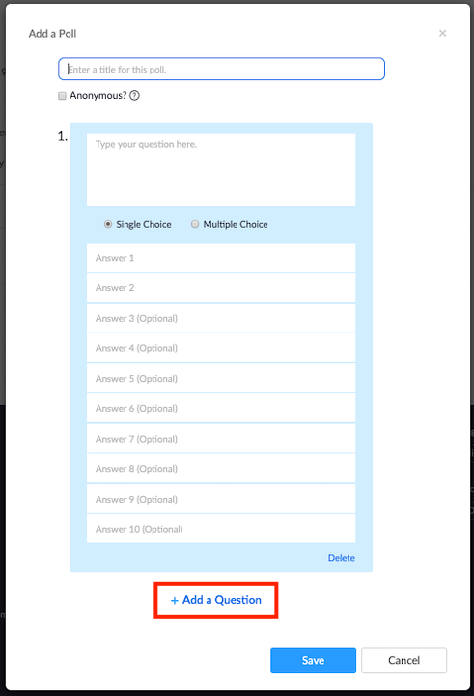
- If you would like to add a new question, click Add a Question to create a new question for that particular poll.

- You can add more polls if you would like to, by repeating step 3.
Launching a Poll
- During your scheduled meeting (for which you created the poll), click Polls in the meeting controls.

- Select the poll you would like to launch.
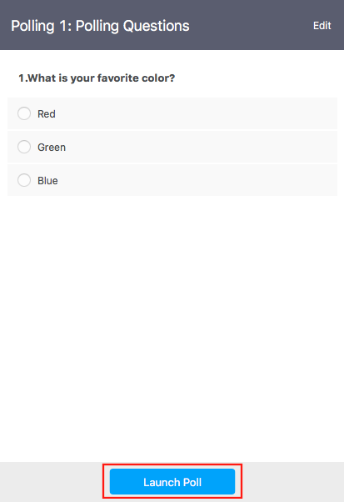
- Click Launch Poll.

- The participants in the meeting will now be prompted to answer the polling questions. The host will be able to see the results live.
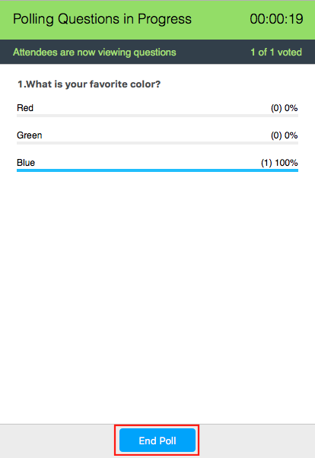
- Once you would like to stop the poll, click End Poll.
- If you would like to share the results to the participants in the meeting, click Share Results.
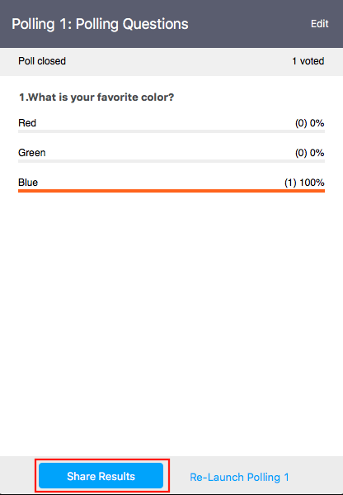
- You can download a report of the poll results after the meeting, but the format is very confusing. I’d recommend just taking a screenshot of the results during the meeting (just paste it into a Word doc).

Using the Cohosting Feature
Co-hosting is a Zoom Pro feature that’s super useful. It allows you as the host to share hosting privileges with another person on the call, meaning they can take care of the administrative side of the meeting – such as managing participants (muting them, admitting them from the waiting room etc.), starting and stopping recordings and so on – to leave you to get on with leading or training. You can have as many co-hosts as you like in a meeting.
Again, you’ll need to make sure this feature is enabled on your account before your meeting.

Enabling Cohosting
- Sign in to the Zoom web portal at https://zoom.us/signin.
- Go to Settings, then In Meeting (Basic)
- Find the Co-Host option, and make sure it’s enabled by toggling the slider to blue.

Making someone a Co-host in a Meeting
- Hover over a user's video.
- Click the more icon .
- Click Make Co-Host.

Optimising Video & Audio when sharing clips
This is a really simple setting which makes sharing video clips a better experience for your attendees.
- During your screen-share, navigate to the video you are about to show.
- In your control panel, click on More, and then Share computer sound
- In the same menu, click on Optimize Screen Share for Video

